SIMATS ENGINEERING
CO2_ASSESSMENT TOOL3_Application Based Questions

COURSE NAME: Cloud Computing and COURSE CODE: CSA1522
Big Data Analytics

Name | KEERTHANA.L
Register Number | 192521062

COURSE OUTCOME COVERED
CO2: Analyze virtualization architectures to identify performance and security issues in cloud computing environments. (BL3)
Dave's Taxonomy: Manipulation (Level 2) Total Marks: 25
Question Count: 5

Code of Conduct
I KEERTHANA.L-(192521062)(Name / Reg No) certify that this submission is my original work and that I have adhered to the guidelines specified for this assessment.
I understand that any violation of academic integrity rules will result in disciplinary action. Signature of the student: ____________________

Assessment Tasks

Application Based Questions

- A company experiences unpredictable traffic spikes during seasonal sales. Explain how cloud auto-scaling and load balancing can handle this demand efficiently. How does this approach reduce downtime and improve user experience? What role do monitoring tools play in this setup? Relate your answer to a real-world e-commerce scenario.

- An organization wants to store large volumes of backup data securely in the cloud. Discuss how cloud storage solutions ensure durability and data redundancy.
How can encryption and access control protect sensitive backup data?
Explain the cost advantages compared to traditional storage systems. Provide an example of a disaster recovery use case.

- A mobile app company plans to deploy its application globally. Explain how content delivery networks (CDNs) improve performance and reduce latency. How do edge servers enhance user experience across regions? Discuss how cloud providers support global availability. Relate this to a real-time streaming or gaming application.

- A financial institution requires strict compliance and data security in cloud usage. Explain how cloud providers support regulatory compliance and auditing. What role do logging, monitoring, and encryption play in security? How can the company ensure data sovereignty requirements are met? Give an example involving sensitive financial transactions.
- A development team wants to adopt containerization for application deployment. Explain how containers differ from virtual machines in terms of performance and resource usage. How does orchestration (like Kubernetes) simplify deployment and scaling? Discuss portability benefits across different cloud environments. Provide an example of a microservices-based application.

Application Based Questions Rubric
Criteria | Weightage | Level 4 -  Exemplary | Level 3 -  Proficient | Level 2 -  Developing | Level 1 -  Beginning
Relevance to Application | 25% | Response directly addresses the given use case with strong relevance | Mostly relevant response | Partially relevant | Weak  relevance
Use of Cloud Concepts | 25% | Applies appropriate concepts accurately | Mostly accurate application | Basic application only | Incorrect concept usage
Practical Insight | 20% | Shows strong real-world understanding | Shows reasonable practical understanding | Limited practical insight | No practical insight
Completeness | 15% | Response covers all required aspects | Covers most aspects | Covers only basic aspects | Incomplete response
Clarity | 15% | Clear and concise answer | Generally clear | Some  confusion in expression | Poor clarity

1.A company experiences unpredictable traffic spikes during seasonal sales. Explain how cloud auto-scaling and load balancing can handle this demand efficiently. How does this approach reduce downtime and improve user experience? What role do monitoring tools play in this setup? Relate your answer to a real-world e-commerce scenario.

Smart Traffic Management in Cloud
Basic Architecture
Customers → Load Balancer → Auto-Scaling Servers → Database
The load balancer works like a traffic controller. It receives requests from customers and sends them to available servers. Auto-scaling adds or removes servers depending on the traffic.
How the System Responds
Suppose an online store normally has 3 servers. During a festival sale, the number of customers suddenly increases. The cloud detects the higher workload and can increase the servers from 3 to 6 or more.
The load balancer then shares the customers between these servers. When the sale finishes and the number of customers decreases, the extra servers are removed.
Monitoring the System
Monitoring tools continuously check the system, such as:
- Number of users
- CPU usage
- Memory usage
- Response time
- Server availability
If the workload becomes too high, the system can trigger scaling automatically.
Real-Life Example
Consider an online store selling mobile phones during a flash sale. At 10 AM, thousands of customers may try to buy the same phone. Without proper traffic management, the website may become slow or unavailable.
With cloud auto-scaling, additional servers are started. The load balancer distributes customers between them. Therefore, customers can browse, place orders, and make payments without major interruption.
Benefits:
- Handles sudden traffic easily.
- Reduces server overload.
- Prevents downtime.
- Improves customer experience.
- Uses resources according to demand.
Challenges:
- Cloud cost can increase during heavy traffic.
- Wrong scaling settings may affect performance.
Final Idea
The complete process is simple:
More Customers → More Servers → Traffic Distributed → Better Performance
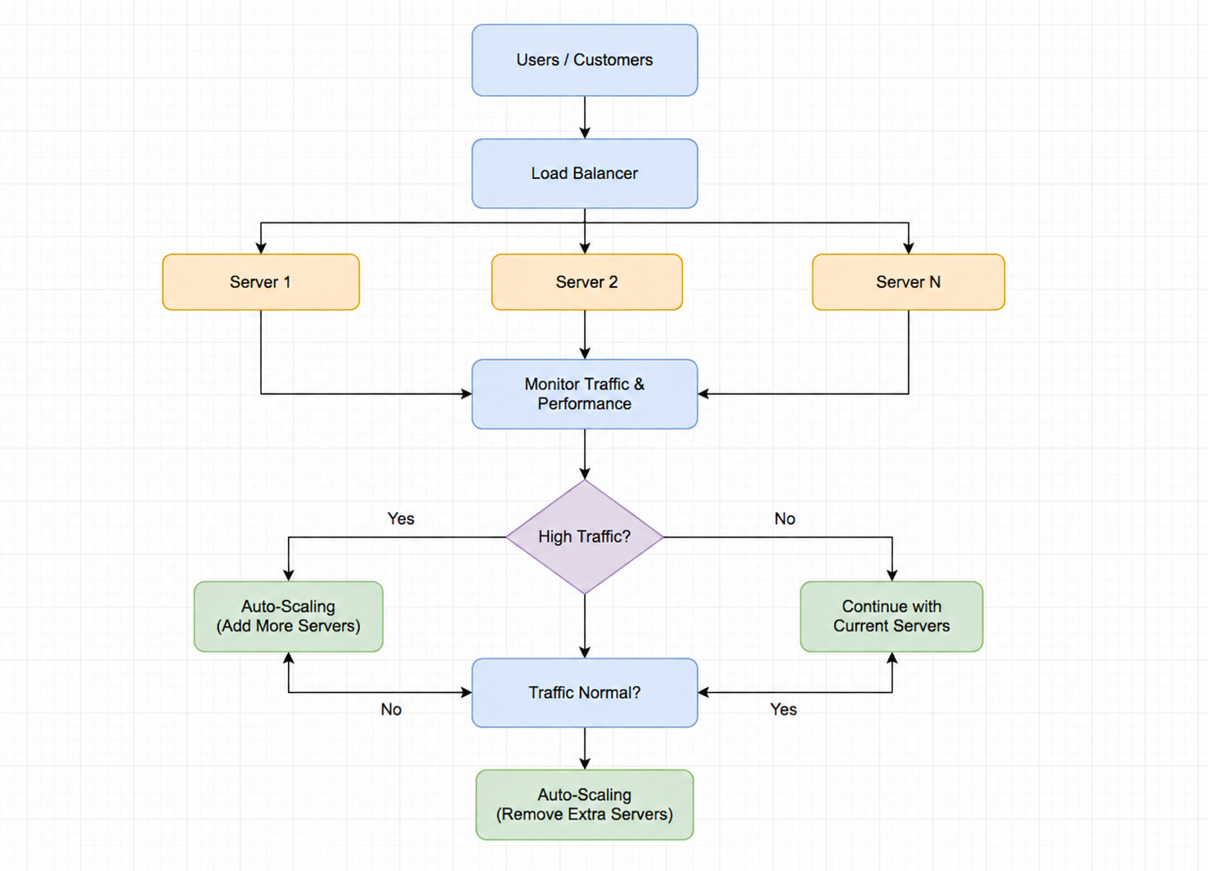

2.An organization wants to store large volumes of backup data securely in the cloud. Discuss how cloud storage solutions ensure durability and data redundancy.
How can encryption and access control protect sensitive backup data?

Secure Cloud Storage for Backup Data
Architecture:
Company Data → Encryption → Cloud Storage → Backup Copies → Disaster Recovery
The company's important data is first encrypted and then stored in cloud storage. The cloud provider keeps multiple copies of the data in different storage locations. If the original data is lost or damaged, a backup copy can be recovered.

Durability and Data Redundancy:
Cloud storage provides durability by protecting data from hardware failures and accidental damage. Multiple copies of the backup can be stored in different servers or locations.
Data redundancy means keeping more than one copy of the same data. If one storage device fails, another copy can be used. This reduces the chance of permanent data loss.

Security of Backup Data:
Encryption changes the data into an unreadable form. Only authorized users with the correct key can access the original information.
Access control decides who can view, modify, or download the backup. For example, only the system administrator may be allowed to restore important company data.
Cost Advantage
Traditional storage requires companies to purchase physical servers, hard disks, maintenance, electricity, and additional space. Cloud storage reduces these requirements.
The company can pay mainly for the storage it uses and can increase or decrease storage according to its needs. Therefore, cloud backup can reduce infrastructure and maintenance costs.
Disaster Recovery Example
Imagine a company stores its customer and transaction records in the cloud. Due to a hardware failure or natural disaster, its main office systems become unavailable.
The company can use the cloud backup to restore the required data and continue its operations. This helps reduce data loss and business interruption.
Advantages:
- Protects data from hardware failure.
- Provides multiple backup copies.
- Supports secure remote access.
- Reduces physical storage requirements.
- Lower maintenance cost.
Disadvantages:
- Cloud storage requires a reliable internet connection.
- Large-scale storage can become costly over time.
- Poor access settings can create security risks.
Final Idea
Encrypt → Store → Duplicate → Protect → Recover
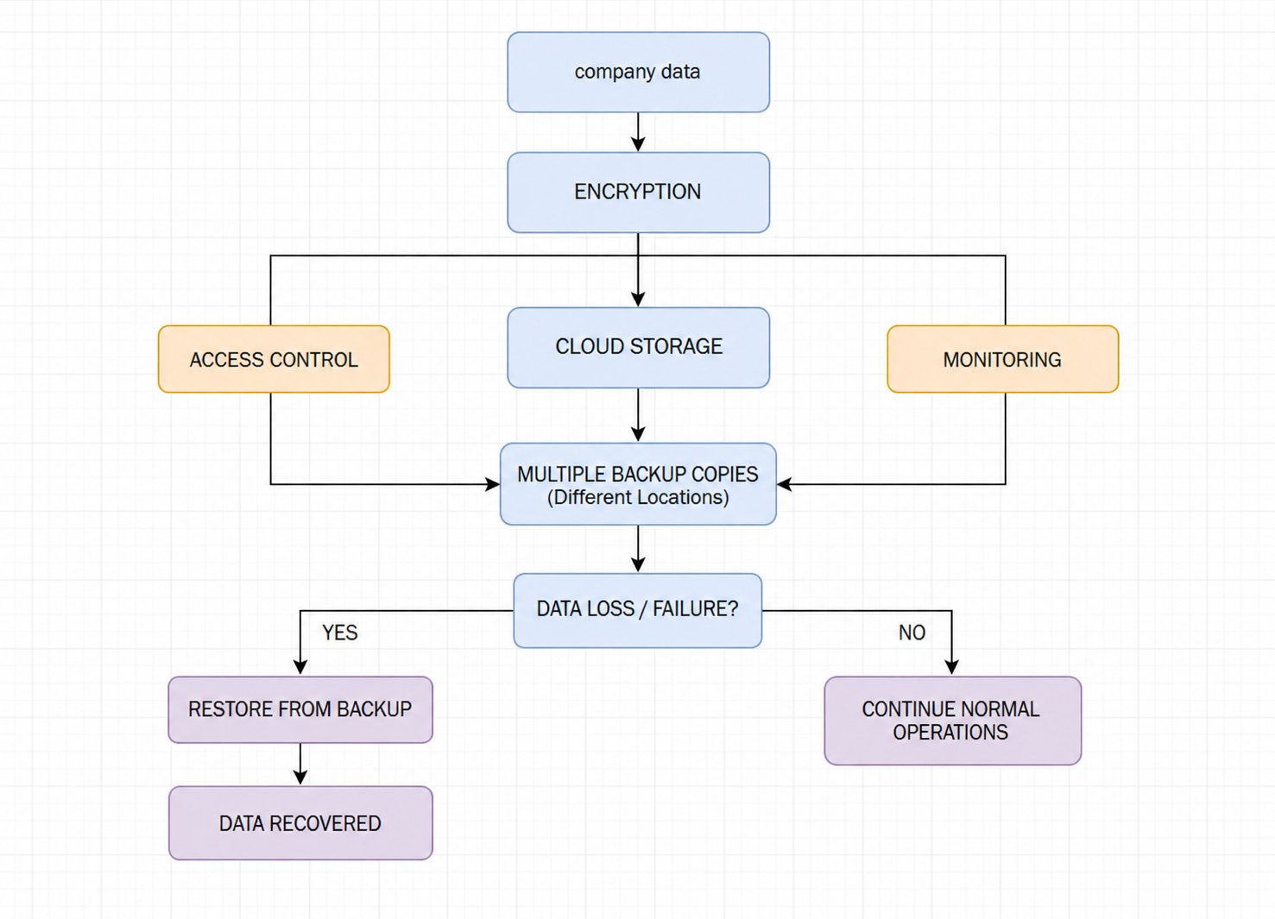

3.A mobile app company plans to deploy its application globally. Explain how content delivery networks (CDNs) improve performance and reduce latency. How do edge servers enhance user experience across regions? Discuss how cloud providers support global availability. Relate this to a real-time streaming or gaming application

Faster Global Access Using CDN
Architecture
User → Nearest CDN Edge Server → Cloud → Main Application
The user does not always need to contact the main cloud server. The CDN first checks whether the required content is available at a nearby edge server. If it is available, the content is delivered directly to the user.

CDN as a Nearby Delivery Point
A CDN can be compared to having small delivery centers in different cities. Instead of sending every order from one central warehouse, the nearest delivery center serves the customer.
Similarly, CDN stores frequently requested content such as videos, images, game files, and web pages at different edge locations. Users receive the content from a nearby location.

Reducing Delay
If a user in India requests content from a server located in another country, the data has to travel a longer distance. This can increase latency.
With a CDN, the same content may already be available at an edge server closer to the user. Therefore, the content reaches the user faster and reduces loading time, delay, and buffering.

Global Cloud Support
Cloud providers maintain infrastructure in multiple geographical regions. This allows applications to serve users from different parts of the world.
If users are located in India, Europe, and America, they can be served through nearby cloud or edge locations rather than depending on a single distant server.

Real-Time Example – Online Gaming
Consider a multiplayer online game with players from India, Japan, and Europe. Game updates, maps, images, and other resources can be delivered through nearby edge servers.
Players can download game resources faster, and the main cloud server receives less traffic. This creates a smoother gaming experience.

Benefits:
- Faster content delivery.
- Lower network delay.
- Better performance for global users.
- Reduces load on the main cloud server.
- Useful for streaming and gaming.

Limitations:
- CDN service adds some cost.
- Cached content may become outdated if not updated properly.
- Dynamic content may not always benefit from caching.

Final conclusion:
Think of CDN as “bringing the content closer to the user.”
Instead of:
User → Far-away Main Server → User
the system uses:
User → Nearby Edge Server → User
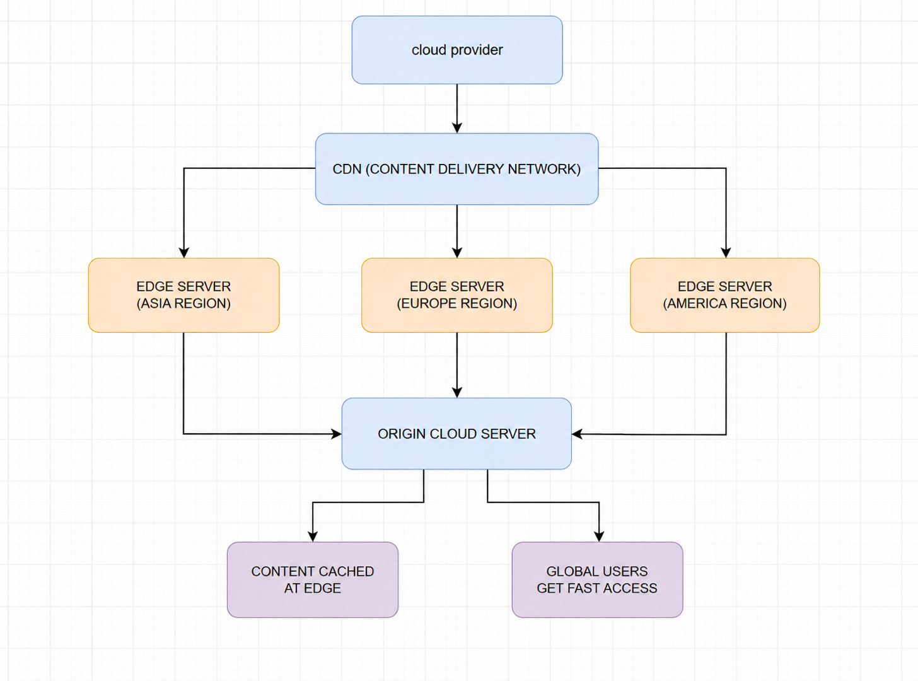

4.A financial institution requires strict compliance and data security in cloud usage. Explain how cloud providers support regulatory compliance and auditing. What role do logging, monitoring, and encryption play in security? How can the company ensure data sovereignty requirements are met? Give an example involving sensitive financial transactions.

Security Architecture
Customer → Banking Application → Encryption → Cloud Services → Secure Database
A financial institution stores sensitive information such as account details, transaction records, and customer information in the cloud. The cloud environment must protect this data and also follow financial regulations.
Compliance and Auditing
Cloud providers offer security controls and compliance features that help organizations follow required regulations. The bank can use these controls to manage who can access data and how the data is stored.
Auditing helps the bank check what happened in the system. It can identify who accessed information, when it was accessed, and what changes were made. This creates an activity record for security checks and audits.
Logging and Monitoring
Logging records important activities such as login attempts, data access, and changes to financial records.
Monitoring continuously checks the cloud environment for unusual activity. For example, if an employee account suddenly tries to access a large number of customer records, the system can generate an alert.
This helps the bank detect security problems quickly.
Encryption and Access Control
Encryption protects data by converting it into an unreadable form. Even if someone gets access to the stored data, they cannot easily understand it without the required key.
Access control ensures that employees can access only the information required for their job. For example, a customer-service employee may view basic customer details but should not have permission to modify transaction records.
Data Sovereignty
Data sovereignty means keeping data according to the legal requirements of the country or region where it is required to be stored.
For example, if a bank must keep certain customer information within India, it can select suitable cloud regions located in India and apply appropriate storage and access policies.
Banking Example
Consider a customer transferring ₹50,000 through a mobile banking application. The transaction is encrypted while being transmitted and stored. Access controls ensure that only authorized systems and employees can access the transaction information.
The activity is also logged. If an unusual transaction or unauthorized access occurs, monitoring systems can detect it and alert the security team. Audit records can later be used to investigate the incident.
Benefits:
- Protects sensitive financial information.
- Helps meet regulatory requirements.
- Detects suspicious activities.
- Provides records for auditing.
- Controls access to important data.
Challenges:
- Security configuration must be maintained properly.
- Compliance requirements can be complex.
- Strong security controls may increase management effort.
Final Idea
For a financial institution, cloud security is not only about protecting data. It is also about proving that the data is protected and that the organization follows the required rules.
Encrypt → Control Access → Monitor → Record → Audit

5.A development team wants to adopt containerization for application deployment. Explain how containers differ from virtual machines in terms of performance and resource usage. How does orchestration (like Kubernetes) simplify deployment and scaling? Discuss portability benefits across different cloud environments. Provide an example of a microservices-based application

Containerization for Modern Application Deployment
Architecture
Users → Load Balancer → Kubernetes → Containers → Microservices → Database
A container packages an application together with the libraries and files it needs to run. Kubernetes manages these containers and makes sure the required services are running properly.
Containers vs Virtual Machines
A virtual machine (VM) includes a complete operating system for each application. Because of this, VMs usually require more memory and storage.
A container shares the host operating system kernel and contains only the application and its required dependencies. Therefore, containers are generally lighter, faster to start, and use fewer resources than VMs.
Virtual Machine | Container
Includes a full OS | Shares the host OS kernel
Uses more resources | Uses fewer resources
Starts more slowly | Starts quickly
Heavier | Lightweight

Kubernetes and Easy Management
When an application has many containers, managing them manually becomes difficult. Kubernetes helps automate this work.
It can:
- Start and stop containers.
- Restart failed containers.
- Increase containers when users increase.
- Reduce containers when demand decreases.
- Distribute workloads across available machines.
For example, if an application normally needs 3 containers but suddenly receives heavy traffic, Kubernetes can increase the number of containers.
Portability Across Clouds
Containers package the application and its dependencies together. Therefore, the same container image can usually be deployed in different environments with fewer changes.
For example:
Developer Laptop → Private Cloud → Public Cloud
This reduces the problem of an application working on one machine but failing on another because of different software environments.
Microservices Example
Consider an online food delivery application. Instead of creating one large application, it can be divided into small services:
User Service | Restaurant Service | Order Service | Payment Service | Delivery Service
Each service can run in its own container. Kubernetes manages these containers independently.
If the payment service receives heavy traffic, more payment-service containers can be created without unnecessarily increasing the other services.
Benefits:
- Lightweight and fast.
- Uses fewer resources than VMs.
- Easy to deploy and scale.
- Supports microservices.
- Portable across cloud environments.
Limitations:
- Kubernetes can be difficult for beginners.
- Container security must be managed carefully.
- Large numbers of containers require proper monitoring.

